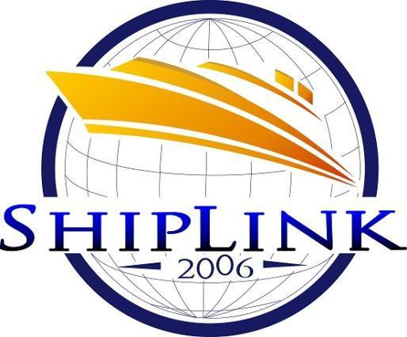

POEA License No. POEA-03-SB-100814-R-MLC

**Office Address:**

Room 609 6th Floor Cattleya Bldg., 235 Salcedo St.,

Legaspi Village, Makati City ,Philippines



**Office:** (632) 8430874 (632) 2180693



**Mobile:** +639179412465 +639393903456



**Email Add:**

[shiplink@shiplinkagency.com.ph](mailto:shiplink@shiplinkagency.com.ph)

[shiplink_agency06@yahoo.com](mailto:shiplink_agency06@yahoo.com)

[shiplinkadmin@shiplinkagency.com.ph](mailto:shiplinkadmin@shiplinkagency.com.ph)

**Website** : [www.shiplinkagency.com.ph](http://www.shiplinkagency.com.ph)

**ABOUT US**

**SHIPLINK AGENCY INC** - Headed by our chairman and president, Engr. Sundayherson G. Ramos is a Filipino owned corporation, started in June 2005, registered with the Philippine Securities and Exchange Commission, licensed to operate by Philippine Overseas Employment Administration (POEA) and the Department of Labor & Employment (DOLE) in September 2006.

Shiplink is also certified by the Philippine government in compliance with the Maritime Labor Convention 2006.

**Our Vision**

Shiplink Agency proposes to be a choice maritime manning agency in the Philippines, to be strongly linked to Ship Owners, Principals and competent Filipino Fishermen.

**Our Mission**

Shiplink Agency is committed in providing quality service to our customers as a choice maritime manning agency in the Philippines.

We have dedicated our quality services, to be an ambassador for fishermen to the world of shipping Principals and Ship Owners. Helping to guide our fishermen reach their potential, fulfilling our customers’ high expectations, helping to keep safer ships, cleaner seas by utilizing competency and leadership development programs.

**Our Objectives**

* + - * To provide our manned principal’s vessel with competent, skilled, certificated and medically fit fishermen of good moral character and positive attitude
      * To maintain a proficient pool of shipboard personnel for the security of clients and manpower
      * To foster loyalty and service orientated attitude to our fishermen and staff
      * To help develop Filipino fishermen competency and career developments

**Our Core Values**

**S - Service Orientated**

**H - Honesty**

**I - Integrity**

**P - Professionalism**

**S - Synergy**

**Company’s Quality Policy**

Our objectives are only possible through the commitment of all office and sea based staff within the company.

**Our Commitment, Our Policies:**

The company is committed in complying with the laws of a corporation, within the Republic of the Philippines including the company’s own laws. We maintain to be a responsible manning agency with the rules and regulations of the Philippine Overseas Employment Agency (POEA).

1. **Commitment to the well-being of our people**

We believe that ‘well-being’ is the cornerstone of personal and professional growth. Without a positive well-being, our objectives cannot be met.

1. **Commitment to the team objective**

We believe in total commitment to the team. The team objective guides us to follow through with our service to our principals/clients, support and allow for team growth.

1. **Commitment to goal attainment**

We believe every individual should have personal and economic goals. Managers and staff work within the framework of daily evaluation in order to identify and achieve our long term objectives.

1. **Commitment to our time management system**

We believe our time management system should be utilized in all operations and activities to provide maximum efficiency and effectiveness for our clients. We are committed to managing our time and setting specific goals within specified timeframes.

1. **Commitment to excellence**

With our philosophy, we become team members, working for ourselves and for each other. We have set high expectations in terms of conduct and know that each of us is a reflection of the team. We extend our excellence not only to our clients/principals, we also look for opportunities where we can assist our employees, fishermen and their families.

1. **Commitment from everyone to be the company’s ambassadors of good will**

We believe that each team member can be a sales person. Spreading our message and the good image of the company by word of mouth. This is a vital prerequisite for our marketing/advertising, leading to our professional success.

1. **Commitment to innovation**

We believe our strength lies in our passion to implement new ideas and welcome change. We accept that innovation involves risks and failures but we choose to take risks to learn from our mistakes and be ready to accept success.

1. **Commitment in respecting personal beliefs**

We are committed in respecting many forms of beliefs, religions and faiths.

**LICENSES AND REGISTRATIONS**

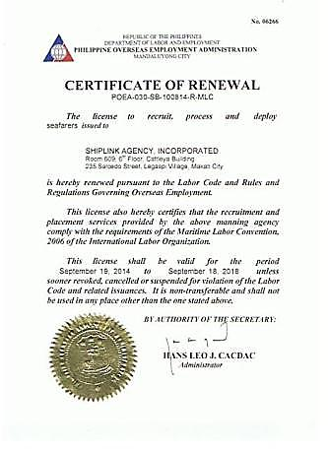

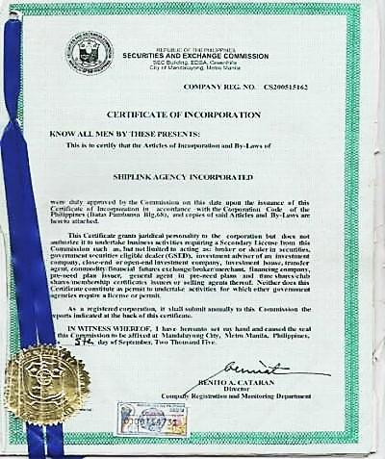

**Current Principals and the Number of vessels with crew onboard**



**I.**

STRATO MARITIME SERVICES

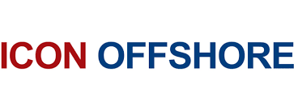 CREST SUBSEA INTERNATIONAL

**II.**

Icon Aliza

**III. Momentum Maritime Services Ltd.**

Gulf Storm

Gulf Spring

Sea Angel

**IV. Mistral Shipping Services Lt.**

MV Mistral

**V. OCEAN GRACE CO. PTE LTD.**

Chin Yung Wen

**VI. INTRA OIL SERVICES BERHAD**

Perdana Voyager

Perdana Expedition

**VII. Harkham Shipping Line LLC**

MV Jada

**VIII. Almeida Shipping GMBH**

MV San Remo

**SHIPLINK AGENCY TEAM AND FACILITIES**

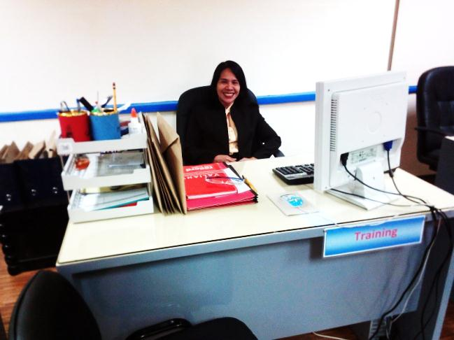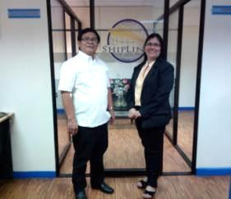

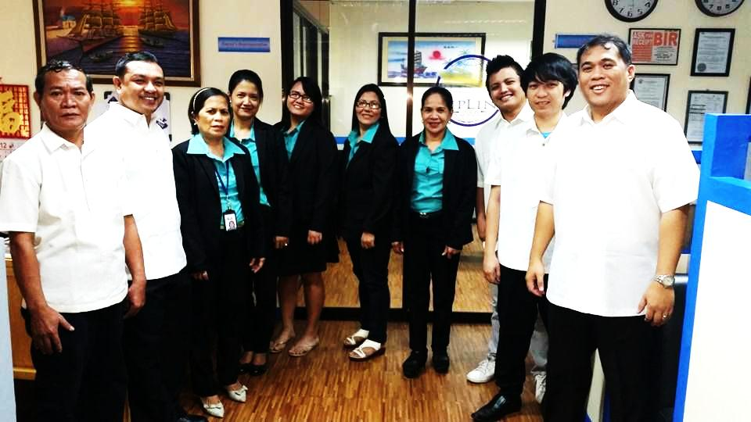

**OUR PEOPLE**

**We value Team Work and We work professionally.**

**Nothing more, nothing less.**

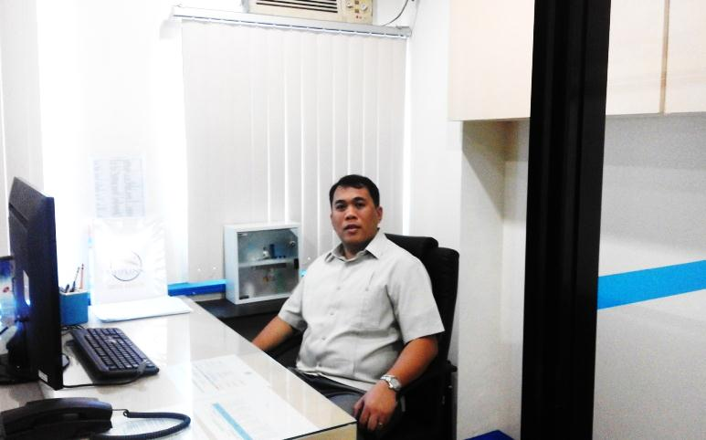

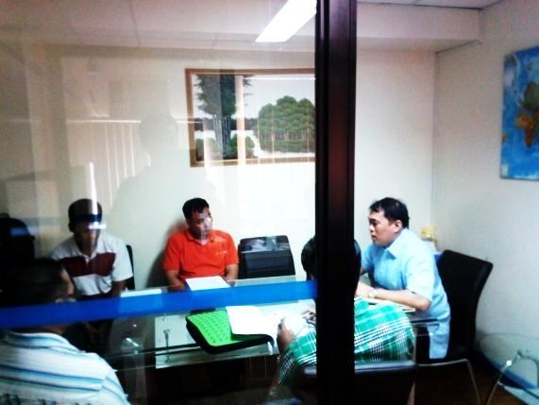

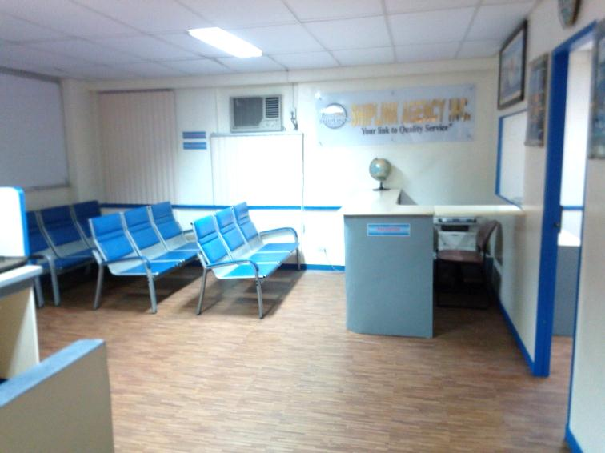 **FACILITIES**

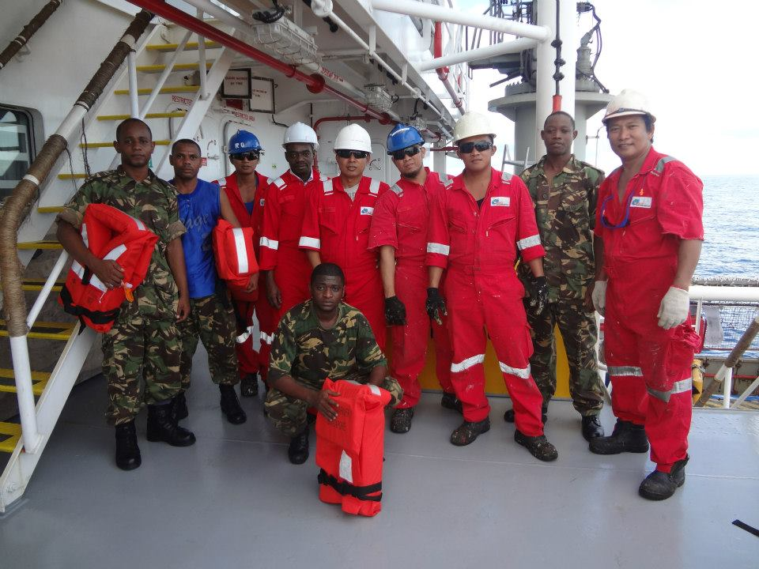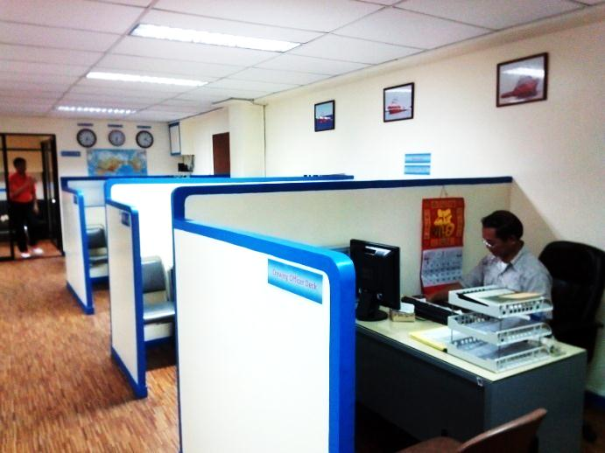 **OUR**

**CREW**

